
SRM Institute of Science and Technology
SET A
College of Engineering and Technology
School of Computing
DEPARTMENT OF COMPUTING TECHNOLOGIES
SRM Nagar, Kattankulathur – 603203, Chengalpattu District, Tamilnadu
Academic Year: 2021-2022 (EVEN)
Test: CLAT-1 Date: 4-4-2022
Course Code & Title: 18CSC205J: Operating systems Duration: 1 Period
Year & Sem: II & IV Max. Marks: 25 Marks

Course Outcomes (CO): |  |  |  |  |  |  | At the end of this course, learners will be able to:
CO-1 : |  | Express the fundamental concepts in operating system
Program Outcomes (PO)
1 | 2 |  | 3 | 4 | 5 | 6 |  | 7 | 8 | 9 | 10 | 11 | 12 | PSO
Engineering Knowledge | Problem Analysis |  | Design & Development | Analysis, Design, Research | Modern Tool Usage | Society & Culture |  | Environment & Sustainability | Ethics | Individual & Team Work | Communication | Project Mgt. & Finance | Life Long Learning | PSO - 1 | PSO - 2 | PSO – 3
3 |  |  | 3 |  |  |  |  |  |  |  |  |  |  | 2

Part - A
(5 x 1 = 5 Marks)
Instructions: Answer all
Q. No | Question | Marks | BL | CO | PO | PI Code
1 | In Unix, Which system call creates the new process?  - Fork  - Create  - New  - None of the mentioned | 1 | 1 | 1 | 1 | 1.6.1
2 | What is the ready state of a process?  - When process is scheduled to run after some execution  - When process is unable to run until some tasks has been completed  - When process is using the CPU  - None of the mentioned | 1 | 1 | 1 | 1 | 1.6.1
3 | A Process Control Block (PCB) does not contain which of the following?  A. Code  B. Stack  C. Bootstrap program  D. Data | 1 | 1 | 1 | 1 | 1.6.1
4 | What is inter-process communication?  - Communication within the process  - Communication between two processes  - Communication between two threads of same process  - None of the mentioned | 1 | 1 | 1 | 1 | 1.6.1
5 | A process stack does not contain __________  - Function parameters  - Local variables  - Return addresses  - PID of child process | 1 | 1 | 1 | 1 | 1.6.1
Part – B
(5 x 4 = 20 Marks)
Instructions: Answer any 5
6 | Relate the different scenario in which the currently executing process moves to ready queue.  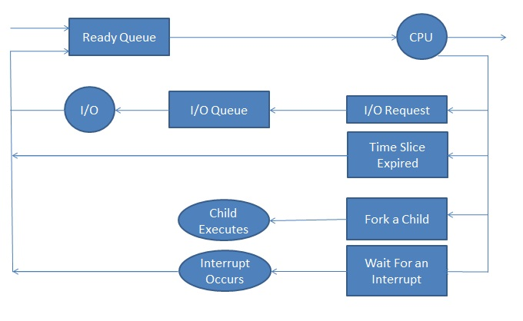  - A new process is initially put in the ready queue. It waits there until it is selected for execution, or is dispatched.  - Once the process is allocated the CPU and is executing, one of several events could occur:  - The process could issue an I/O request and then be placed in an I/O queue.  - The process could create a new subprocess and wait for the subprocess's termination.  - The process could be removed forcibly from the CPU, as a result of an interrupt, and be put back in the ready queue.  - A process continues this cycle until it terminates, at which time it is removed from all queues and has its PCB and resources deallocated. | 4 | 3 | 1 | 1 | 1.7.1
7 | Compare Batch Multiprogramming versus Time Sharing  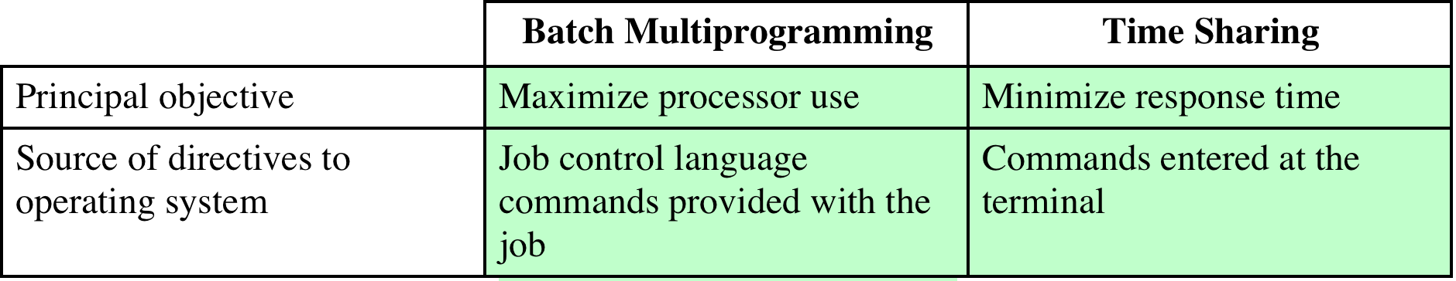 | 4 | 4 | 1 | 2 | 2.6.4
8 | With a neat sketch brief Key Elements of an Operating System  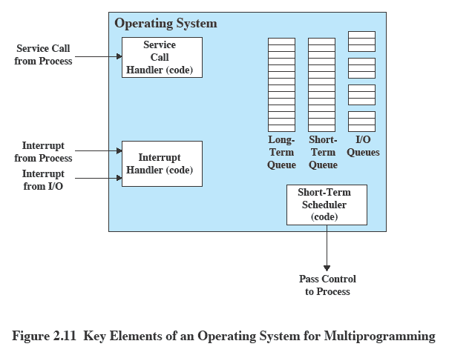 | 4 | 3 | 1 | 2 | 2.6.2
9 | Illustrate the key aspects of Symmetric Multiprocessor OS Considerations  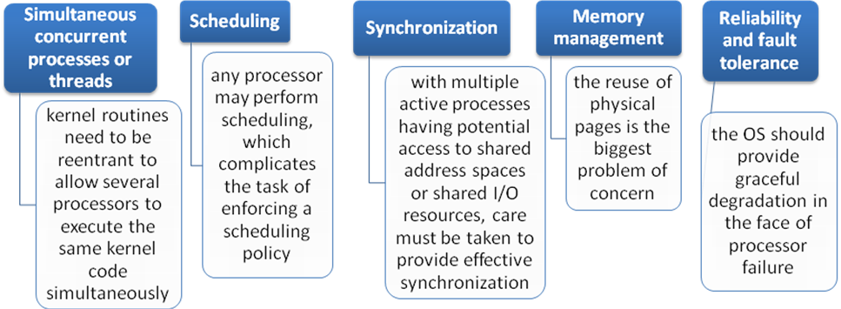 | 4 | 2 | 1 | 2 | 2.6.2
10 | Explain about Process Synchronization  - Process Synchronization means sharing system resources by processes in a such a way that, Concurrent access to shared data is handled thereby minimizing the chance of inconsistent data. Maintaining data consistency demands mechanisms to ensure synchronized execution of cooperating processes.  In other ways,  - Processes can execute concurrently  - May be interrupted at any time, partially completing execution  - Concurrent access to shared data may result in data inconsistency  - Maintaining data consistency requires mechanisms to ensure the orderly execution of cooperating processes  Illustration of the problem:  Suppose that we wanted to provide a solution to the consumer-producer problem that fills all the buffers. We can do so by having an integer counter that keeps track of the number of full buffers. Initially, counter is set to 0. It is incremented by the producer after it produces a new buffer and is decremented by the consumer after it consumes a buffer. | 4 | 2 | 1 | 1 | 1.7.1
11 | Justify how mutual exclusion prevent race condition  To avoid race conditions, mutual exclusion must be enforced within critical sections. Prohibits more than one process from accessing shared memory at same time. If no two processes enter their critical sections at same time, no race conditions. For correct and efficient operation using shared data, a solution must ensure that: 1) No two processes can be inside their critical sections at same time.  2) No assumptions needed about relative process speeds or number of CPUs.  3) No process stopped outside its critical section can block other processes.  4) No process can be indefinitely postponed from entering its critical section. | 4 | 3 | 1 | 1 | 1.7.1

